INTERNSHIP REPORT

EXPENSE TRACKER APP

Student Name: Vishnulal C.B
Register Number: PNAYSCS032
Programme: BSC Computer science
College: PRAJYOTI NIKETAN COLLEGE
Internship Organization: Ziuke Infotech
Total Hours Completed: 60 hours
Industry Supervisor(s): Sruthi Sunil

2. Acknowledgement
I would like to express my sincere gratitude to my industry supervisor(s) for their continuous guidance, encouragement, and technical support throughout the internship period. Their valuable suggestions and mentoring helped me understand real-world application development and professional work practices.
I am extremely thankful to the host organization for providing me with the opportunity to work on the Expense Tracker App project. This internship allowed me to gain hands-on experience and apply my academic knowledge to practical scenarios.
I also extend my heartfelt thanks to my internal supervisor and college faculty members for their constant monitoring, motivation, and academic support during the internship. Finally, I thank my family and friends for their encouragement and moral support.

3. Executive Summary
This internship report presents a detailed account of the internship carried out on the development of an Expense Tracker App. The primary objective of the internship was to understand the process of designing and developing a real-time software application that helps users manage and monitor their daily expenses effectively.
During the internship, I analyzed the need for personal financial management applications and studied existing expense tracking systems. The project focused on developing a user-friendly and secure application that enables users to record daily expenses, categorize spending, view summaries, and generate reports. The major modules of the application include user registration and authentication, expense entry, category management, income tracking, budget setting, expense analysis, and report generation.
Various tools and technologies were used throughout the internship, including HTML and CSS for interface design, programming languages for backend logic, MySQL for database management, UML diagrams for system modeling, and MS Word for documentation. Through this internship, I gained practical exposure to requirement analysis, application design, database creation, testing, and documentation.
Overall, the internship enhanced my technical knowledge, improved my problem-solving skills, and provided valuable insights into developing efficient and user-centric financial applications.

4. Internship Certificate

5. Table of Contents
- Organization Profile
- Internship Overview
- Internship Experience
- Learning Reflection
- Appendices

Chapter 1: Organization Profile
The internship was carried out at an organization specializing in software development and IT-enabled services. The organization focuses on building reliable, secure, and user-friendly software applications that solve real-world problems using modern technologies.
The company has experience in developing web-based and mobile applications in domains such as finance, healthcare, education, and utility services. One of its key strengths is developing applications that manage sensitive user data securely, which is especially important for financial applications like expense tracking systems.
The organization follows standard software development life cycle (SDLC) methodologies including requirement analysis, design, development, testing, deployment, and maintenance. Interns are encouraged to understand each phase clearly and participate actively in development and documentation tasks.
The working environment of the organization promotes teamwork, innovation, and continuous learning. Regular reviews, discussions, and feedback sessions help interns improve both technical and professional skills. This supportive environment played an important role in enhancing my learning experience during the internship.

Chapter 2: Internship Overview
Duration
I completed 60 hours of training.
Objectives
The main objectives of the internship were:
- To understand the fundamentals of personal finance management systems
- To analyze user requirements for an Expense Tracker application
- To gain hands-on experience in software development practices
- To design and manage databases effectively
- To improve documentation and reporting skills
Departments Worked In
During the internship, I worked closely with multiple departments:
- Application Development Department: Focused on designing and developing application features
- Database Management Department: Responsible for database creation and data handling
- Testing and Quality Assurance Department: Ensured correctness and reliability of the application
- Documentation Department: Prepared reports and technical documents
Tools and Platforms Used
The following tools and platforms were used during the internship:
- HTML and CSS for creating user-friendly interfaces
- Programming languages such as Java / Python / PHP for application logic
- MySQL for database management and storage
- UML tools for creating Use Case and Class Diagrams
- MS Word for documentation and report preparation
These tools helped in understanding complete application development workflows.

Chapter 3: Internship Experience
Tasks Performed
Requirement Analysis
- Studied existing expense management and budgeting applications
- Identified user needs such as expense categorization, budget alerts, and reports
- Documented functional and non-functional requirements
Application Design
- Designed application modules including user authentication, expense entry, income tracking, budget management, and reporting
- Created basic screen layouts and navigation flow
- Prepared UML diagrams to visually represent system functionality
Database Design
- Designed normalized database tables for users, expenses, income, categories, and budgets
- Defined primary keys, foreign keys, and constraints
- Ensured data accuracy and consistency
Development and Testing
- Assisted in implementing basic application features
- Tested expense entry, update, and report generation functionalities
- Identified bugs and assisted in resolving errors
Key Contributions
- Contributed to designing the Expense Tracker App architecture
- Assisted in database creation and validation
- Supported testing and debugging activities
- Helped in preparing detailed documentation
Challenges Faced
Some challenges faced during the internship included:
- Designing efficient database relationships
- Handling large volumes of expense data
- Ensuring accuracy in calculations and reports
These challenges were overcome through supervisor guidance, teamwork, and continuous practice.
Personal Learning and Observations
The internship enhanced my understanding of real-time application development. I learned the importance of secure data handling, proper planning, systematic testing, and documentation. This experience significantly improved my confidence and technical abilities.

Chapter 4: Learning Reflection
Academic Knowledge vs Practical Experience
Academic learning provided theoretical knowledge in programming, database management, and software engineering concepts. The internship allowed me to apply these concepts practically, such as designing databases, implementing logic, testing applications, and documenting processes.
This practical exposure helped me understand the challenges involved in real-world application development and improved my analytical and problem-solving skills.
Role and Support of Internal Supervisor
The internal supervisor played a significant role by regularly reviewing my work, providing feedback, and clarifying doubts. Their guidance ensured that academic objectives were met and helped me successfully complete the internship.

6. Appendices
Appendix A: Internship Photo
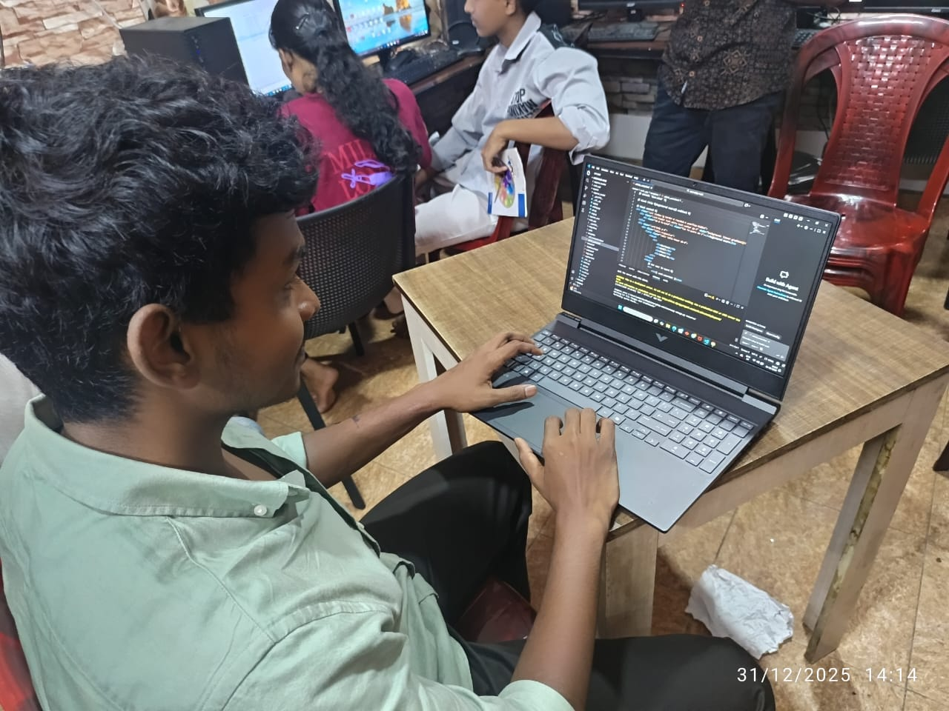

Appendix B: Workbook Summary
click here
Conclusion
The internship on the Expense Tracker App was a highly enriching experience that enhanced my technical knowledge and professional skills. It provided real-world exposure to financial application development and strengthened my ability to design efficient and user-friendly software solutions. This internship has prepared me to face future challenges in the software development field with confidence.

Signature of Student: ______________________
Date: ______________________

